**COMPUTER NETWORKS**

**NAME: M.ISTAFA MALIK**

**ROLL: P190033**

**SECTION: BSCS-5A**

Task: Configuring an IP helper address.

Solution:

Step 1: Topology

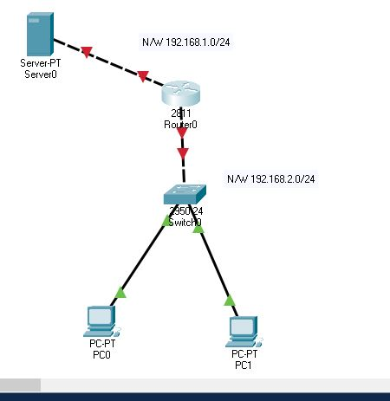

Step 2: Assign Static IP to the Server.

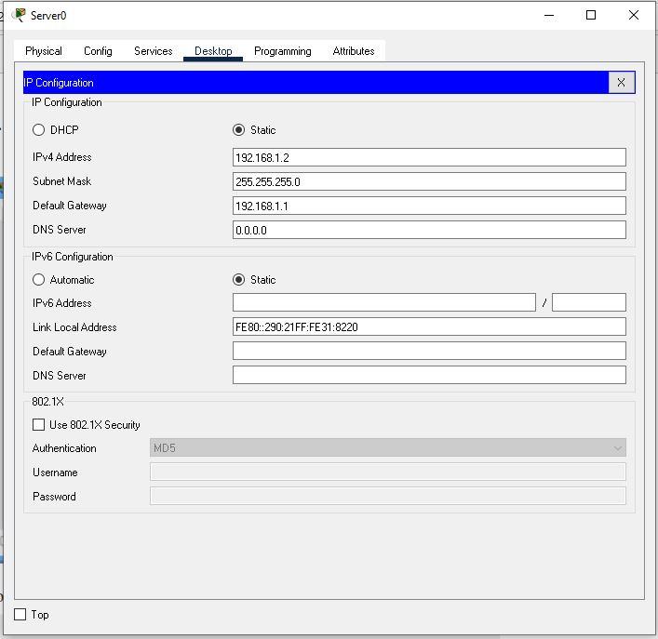

Step 3: Configure the router using following commands.

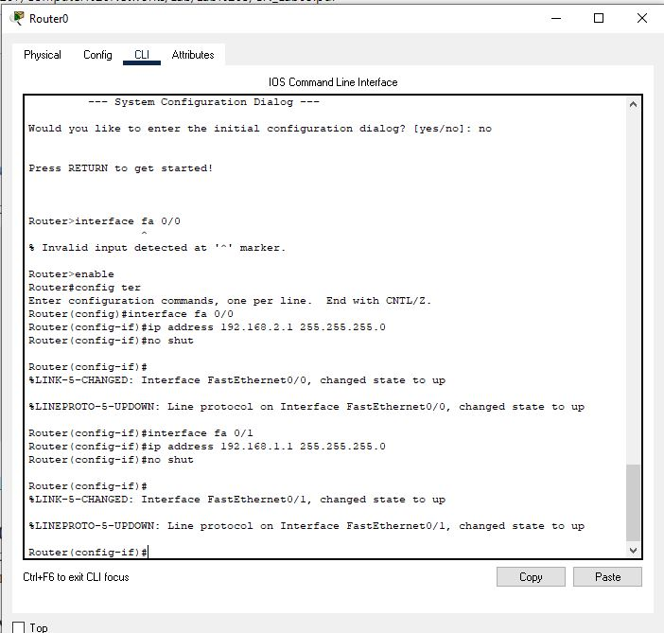

Step 4: Open DHCP in Sever and add the following Pool with the given attributes.

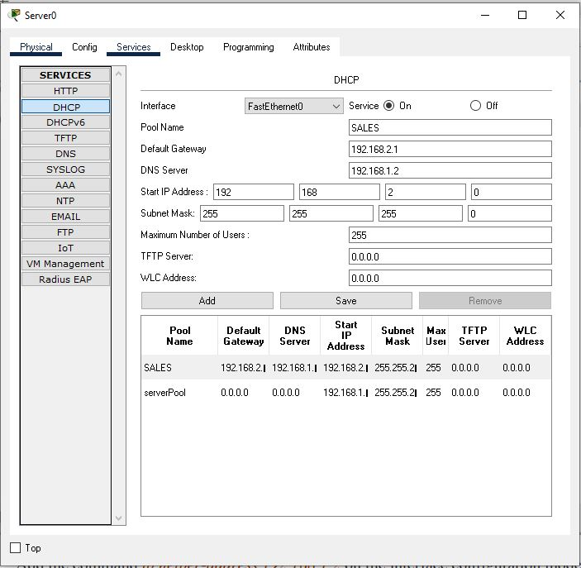

Step 5: Also add this command in router configuration.

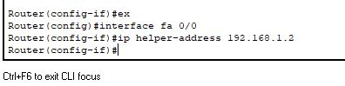

Step 6: Now assign IP to the PC’s using DHCP.

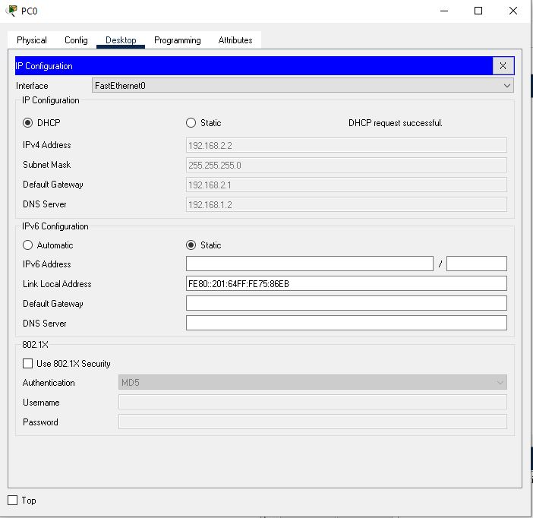

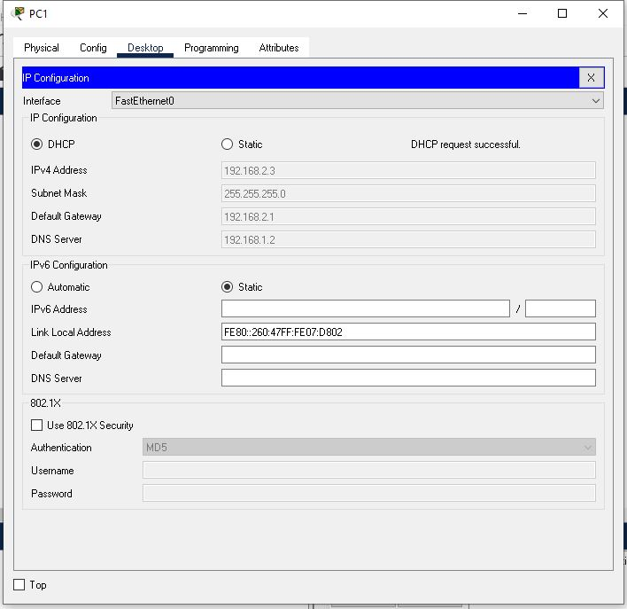

**SUCCESS!!!!!**

Task:

Students should make the scenario exactly implemented in Lab 4 and implement the following:

1. We have three website each of them is stored on separate Web Server, • (www.slate.nu.edu.pk or state.nu.edu.pk) having IP address 192.168.1.5 • (www.pwr.nu.edu.pk or pwr.nu.edu.pk) having IP address 192.168.1.6 • (www.flex.nu.edu.pk or flex.nu.edu.pk) having IP address 192.168.1.7

2. A DHCP server and a DNS server configured as follow: • DHCP IP : 192.168.1.9 • DNS Server IP : 192.168.1.4

3. We are going to make Two Labs “Lab A” and “Lab B”. In each Lab there are three PC’s. We want to use DHCP Server to avoid static IP’s. We also have our own DNS Server. Use the Class C IP Address like 192.168.1.0 or 192.168.2.0

Solution:

Step 1: Topology

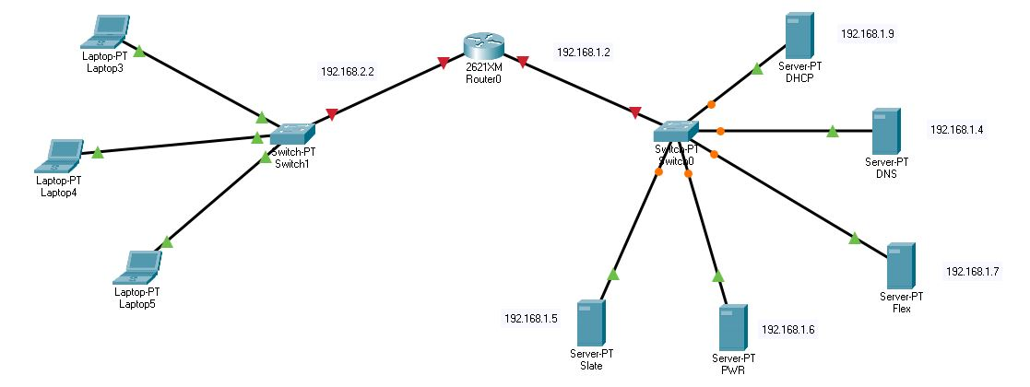

Step 2: Router configuration.

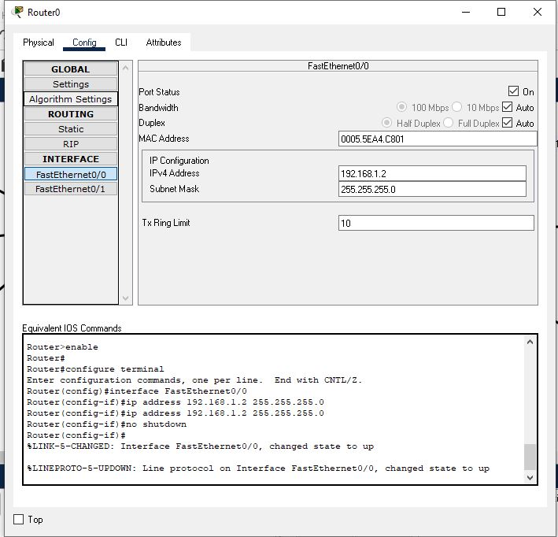

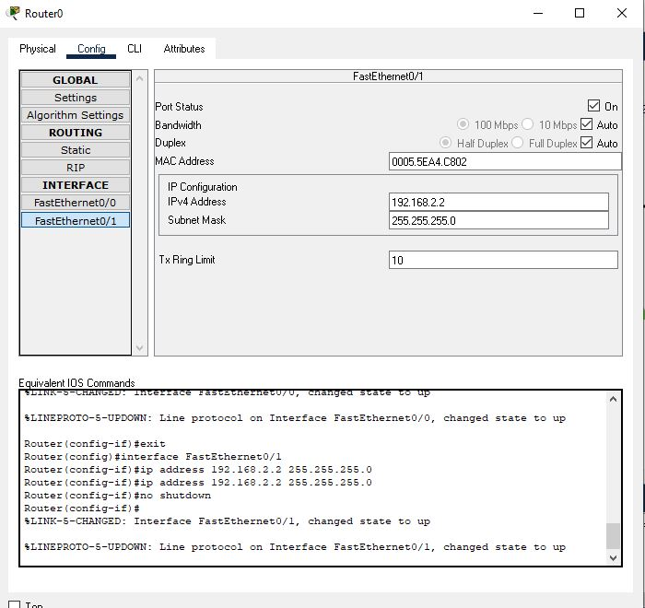

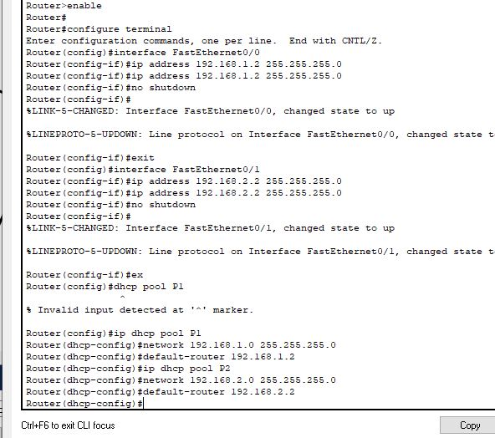

Step 4: Assign static IP to DHCP and Enable DHCP Services and Add Pool P1 and Pool P2 with respective IP Addresses

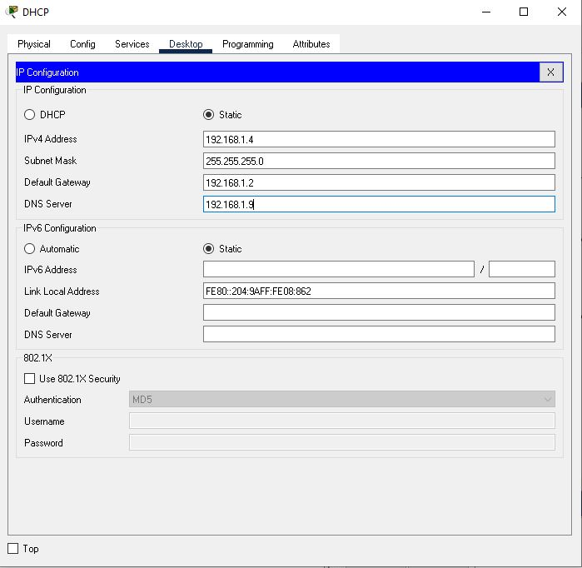

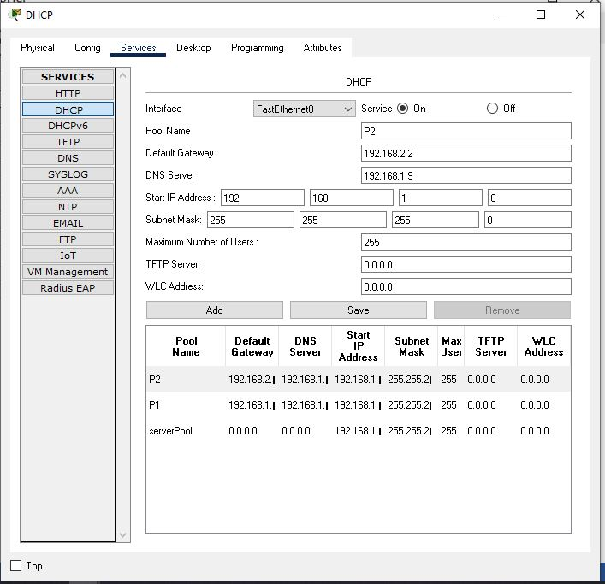

Step 5: Assign Static IP to DNS and Enable DNS Services of DNS and add resources records.

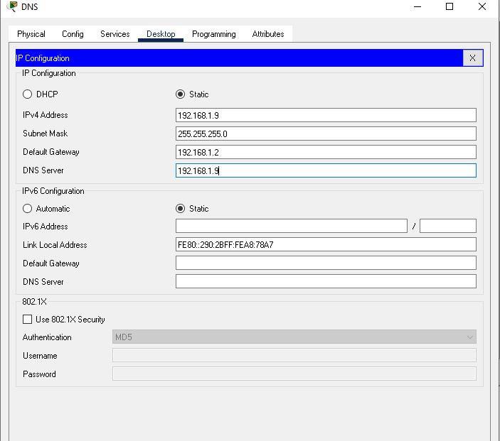

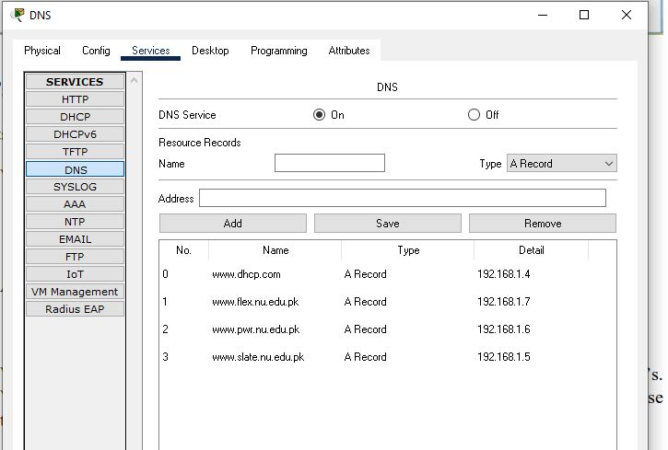

Final Step: Now try assigning IP’s to PC’s using DHCP.

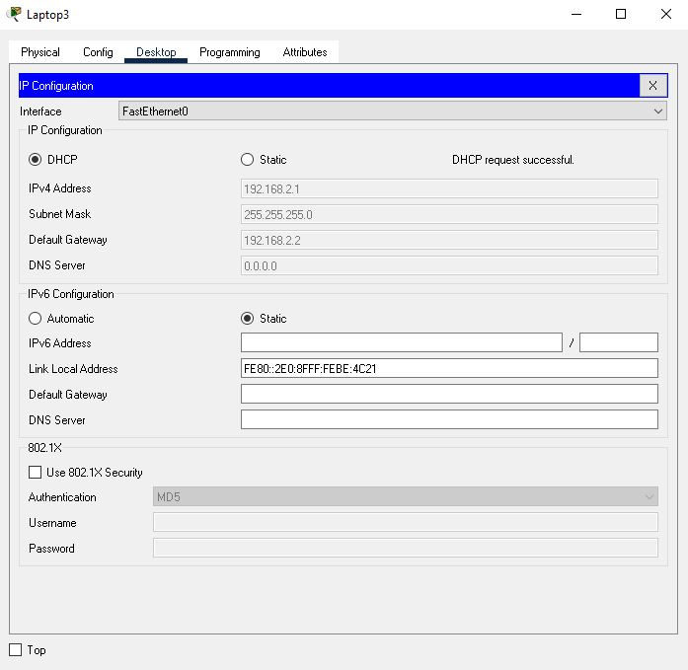

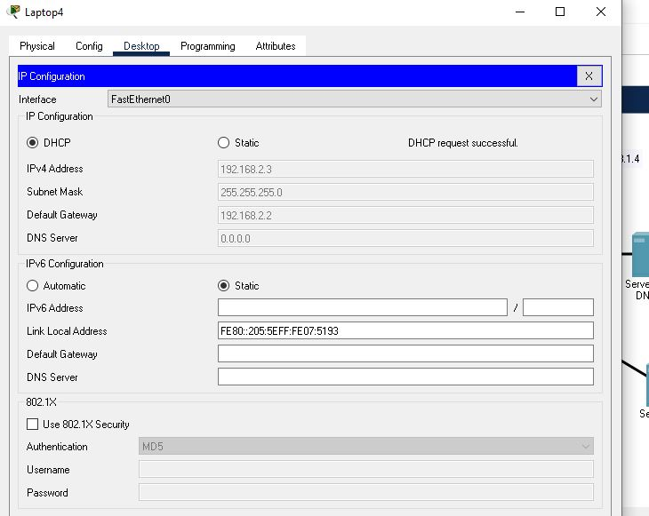

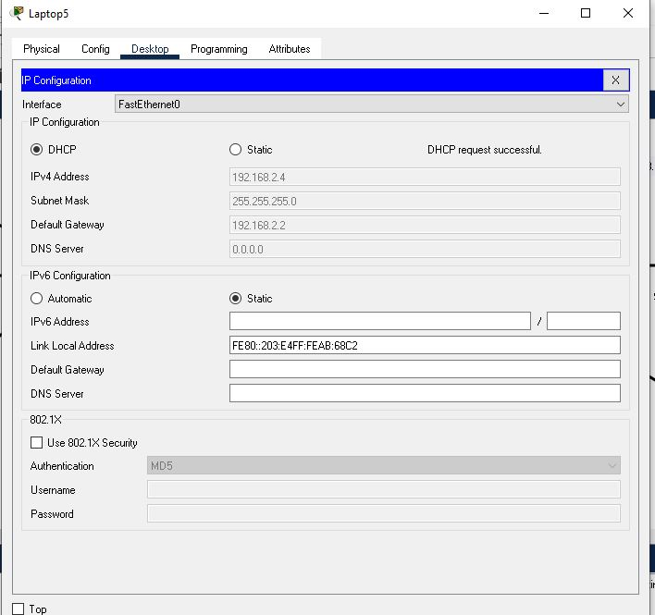

Success!!!!!!!!!!!!!!!!!!!!!!!!!!!!!!!!!!!!!!